
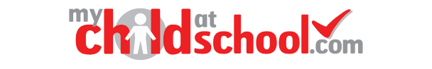
New Starter MCAS set up and Admission Form Completion

New Accounts
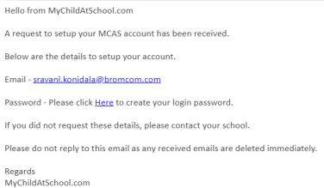
You will have received an email from with a link to the Parent Login screen.

Click “Here” to open the Create Your Password screen.

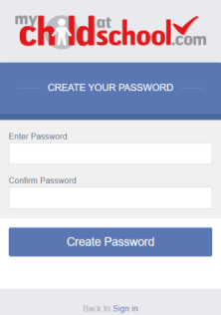
Enter a Password and Confirm Password then click Create Password.

Logging in to MCAS New and Existing accounts
From within a web browser type www.mychildatschool.com or access the MCAS mobile phone app.
This will open the Parent Login screen.
Enter your Email Address and Password.
Use the Email Address registered to the MCAS account and the Password to Login.
Click on the Login button.
Login to the MCAS account and see all Students linked to that Email Address
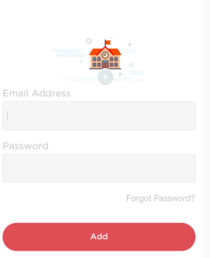
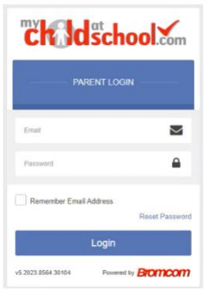
Web View Login App View Login

If you have more than one Profile using the same Email Address, a popup will appear, select the Profile you wish to use to continue to the Dashboard. Students associated with each Profile are displayed on the right-hand side. Note: Hover over the student icons on the right-hand side to see the student's names associated with each Profile.
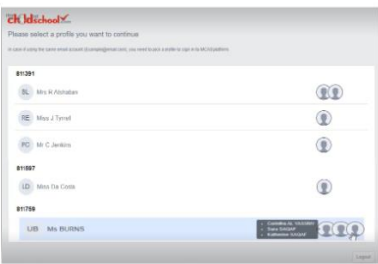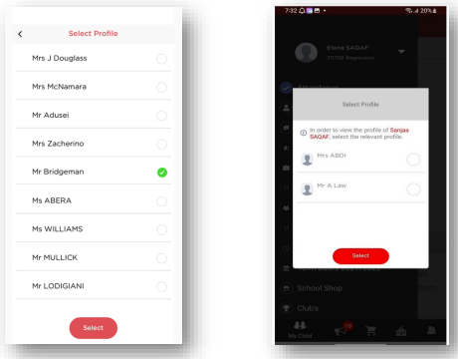
Web View Pop Up App View Pop UP – i0s and Android

Admission Form
Once you have your dashboard open, please navigate to the Admission Form.
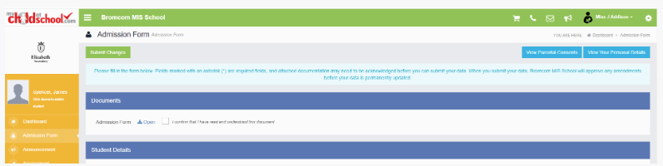
You will note that there are documents attached for you to read, acknowledge and consent to. Please action this before proceeding.

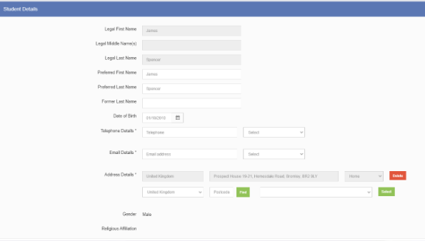
Student Details
This is where you will need to input more information. It is vital that you add all the information requested, so that we have accurate details for your child. We request at least 2 contact details in case we are unable to contact the main carer.

Ensure that all the information relating to your child here is accurate, including country of birth and language(s). It is vital that you enter the child's first (home) language into the first box and select first language.

Please also complete the medical information, including emergency consent and any information relating to Special Educational Needs.
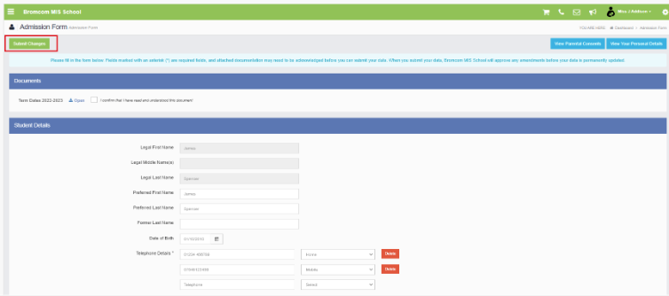
Once you are happy with the information in the Student Details panel click Submit Changes in the top left corner of the screen.

Once our Admin team have approved the Student Details you have submitted, they will show on the Student Details panel, as per the message at the top of the screen.

Personal Details and Adding Contacts

To view or edit your Personal Details with the option to add Contacts click on View Your Personal Details.

Follow the same process as you did for the Student Details panel

If required, click Add Another Contact
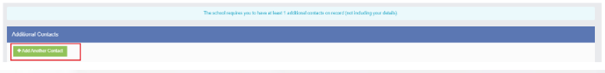

Fill in all the required fields and then click ADD.

Please note adding an additional contact does not create an MCAS account for that person. Our School Admin team will send out invitations once the details have been updated on our records.

Parental Consents
It is vital that you complete your parental consents. Please select “yes” or “no” for each one as you wish but please be aware of the following:

If you do not tick yes for “Consent to Publish Photos, Filming and/or Work” we will not use your child’s photos, filming or work for any displays in and around school, on our social media and websites nor in the local newspapers.

If you do not tick yes for “Consent to take Photos and Film for sale to Parents” we will not include your child in class photos, individual photos and filming such as the Christmas Performances for sale to parents.

If you do not click yes for “School Day Trips” your child will not be able to attend local day trips such as beach trips, park, library etc.)

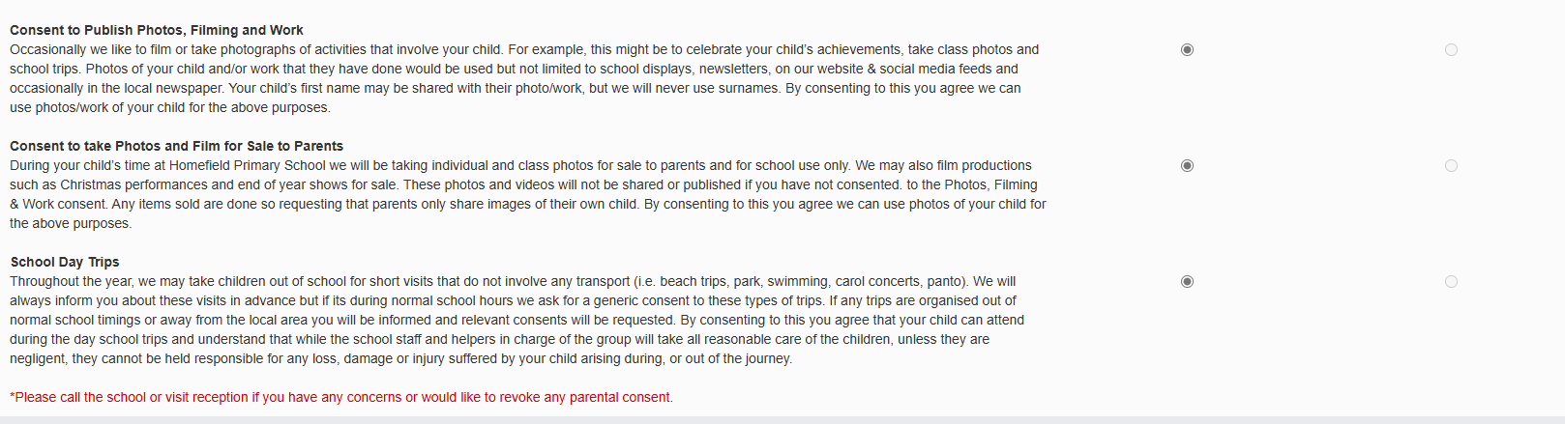
Once you have made your selections please click SAVE.

