13th March 2026

Dear Parents/Carers,

Re: Y6 WW2 Day

We are excited to tell you that we have arranged for the children in Year 6 to participate in a day of activities based around our World War 2 topic.
The day will take place on Friday 27th March 2026.
On this day children will get to enjoy the following activities:
- A billeting experience where the children will see what it was like for children to arrive at a destination and then be billeted to host families.
- School room writing with a dip pen and ink
- A make do and mend sewing session
- A talk from local historian Chris Hare about Worthing during war time
- A celebration of VE Day with scones, cream and jam and a good old cuppa
Date: Friday 27th March 2026
The cost of the day is £2.00 per child and we are asking for a voluntary contribution of this amount to cover the cost. Donations can be made via MCAS (MyChildAtSchool) in the Trips & Events section. Alternatively, we can accept cash donations in a sealed envelope clearly marked with your child’s name at reception.
Clothing and accessories
The children have the opportunity to dress as an evacuee or to come to school dressed in full uniform. If they are not dressing up, uniform is required. We have included some ideas for dressing up below.
We are also challenging the children to bring in a small rucksack or suitcase with their essentials for evacuation – their school bag is a perfect size as children couldn’t bring much with them.
The bag should include: basic clothing, their favourite book or two, a family photo or photo of parents/carers that you do not mind them taking to school, a comforting toy such as a beloved teddy and anything else they can fit in that they think they could not survive without. This must not include any modern items such as phones or electronic devices. We are excited to see what they will bring.
Ideas for WW2 costumes:
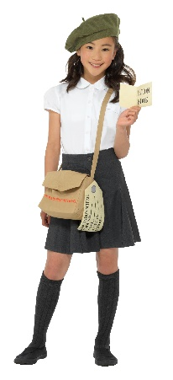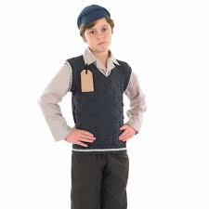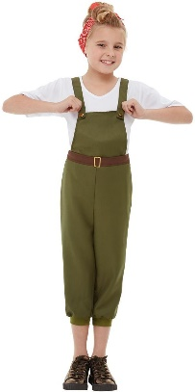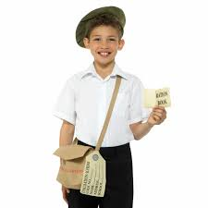
Homemade items would be wonderful; they can make evacuee labels and gas mask boxes. Headscarves, flat caps, jumpers with the arms cut off and plain summer dresses are an easy option if you have them at home or can borrow them.

Yours faithfully,
The Year 6 Team

